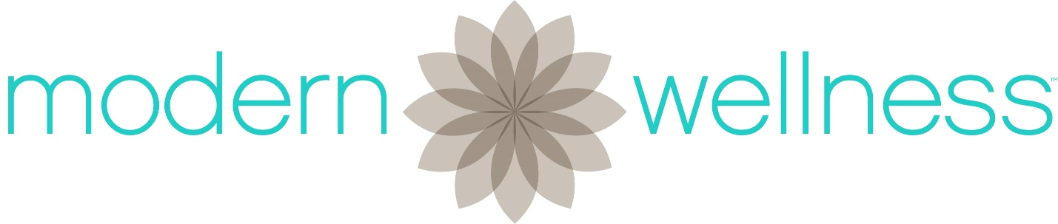

Crisis Contact Information
Modern Wellness Psychotherapy & Healing
333 North Dobson Rd, Suite 5, Chandler, AZ 85224
480-280-8888
Crisis Contact Information
Services at Modern Wellness Psychotherapy & Healing are committed to helping individuals and families cope through the use of psychotherapy. Modern Wellness Psychotherapy & Healing does not provide crisis response or emergent psychological support.
However, some life stressors can be overwhelming. This sheet provides you with crisis phone numbers that you can call 24 hours/day, 7 days per week if you are having an emergency, crisis, or have thoughts of hurting yourself or someone else. Because Modern Wellness Psychotherapy & Healing cares about you and your safety, the following information is being provided and you are being asked to commit to what is below.
Please agree to contact one of the following resources if you find yourself in that situation:
EMPACT Suicide Hotline: 480-784-1500
National Suicide Prevention Hotline: 1-800-273-8255
MMIC Behavioral Health Crisis Line: 602-222-9444
Central Arizona Warm Line: 602-347-1100
BY SIGNING BELOW I AM AGREEING THAT I HAVE READ, UNDERSTOOD AND AGREE TO THE ITEMS CONTAINED IN THIS DOCUMENT.

Signature:___________________________________ Date:_______________________

Witness:____________________________________ Date:_______________________

